Food Closet Volunteers Needed

Looking for a way to get involved in the Palo Alto community? Come volunteer at our Food Closet! Downtown Streets Team operates the Downtown Food Closet out of All Saints’ Episcopal Church at 425 Hamilton Ave. The Food Closet provides food security to our low-income, at-risk, and unhoused community members in Palo Alto, East Palo Alto, and Menlo Park. On average, the Food Closet serves over 400 individuals each month, and we have seen a significant increase in the number of those in need of food since the onset of COVID.

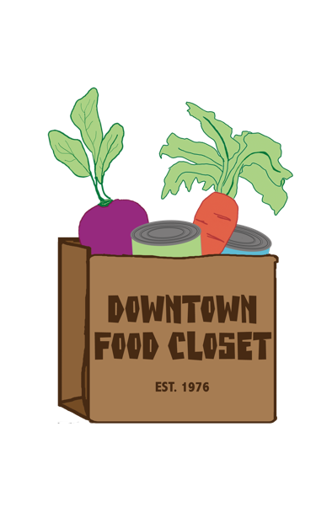
We are in need of volunteer help! We are looking for volunteers who are kind, patient, and have good people skills. Volunteers must be 18 years or older, or 16+ with signed parental consent. We could consider younger volunteers; however, they MUST be accompanied by a parent or legal guardian. The environment in our Food Closet is fun and fast-paced. Spanish-speaking or Mandarin-speaking volunteers are highly desired. Masks and gloves are required at all times.

Typical tasks include, but are not limited to: checking in and serving groceries to clients, prepping/packaging food (NO cooking involved), and light cleaning.

Volunteer hours needed:

Monday and Wednesday – 10:00 am - 3:00 pm***
Tuesday – 12:00 - 2:30 pm
Thursday – 10:00 am – 12:00 pm & 1:00 - 2:30 pm***
Friday – 10:00 am – 1:00 pm

We especially need volunteer help on Monday’s, Wednesday’s, and Thursday’s. Hours can be adjusted according to your schedule. Even if you can only help out for a couple hours here and there within the hours listed above, give us a call!

Please contact Charlotte Coker at (408) 591-7539 or charlotte.ca413@gmail.com for *** these days.

Contact Shirley Reiter at (650) 704-9813 or shirleyreiter@yahoo.com for the other days.

